Redesign the Misleading Colored Chart

R. No: 24 Reg. No: 192424130 Name: Manisha M
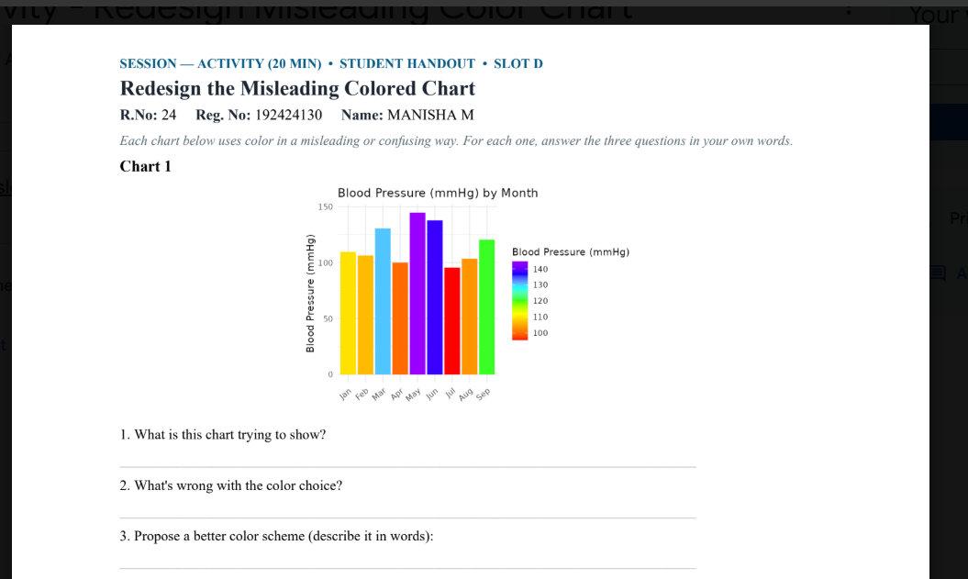
1. What is this chart trying to show?
This chart shows the blood pressure levels recorded from January to September. It helps us compare the blood pressure values for each month.
2. What’s wrong with the color choice?
The chart uses many different bright colors for the bars. This makes the chart look confusing and makes it difficult to focus on comparing the blood pressure values.
3. Propose a better color scheme (describe it in words):
A better choice would be to use one simple color, such as blue, for all the bars. A darker shade can be used to highlight the highest value. This would make the chart clear, simple, and easy to understand.

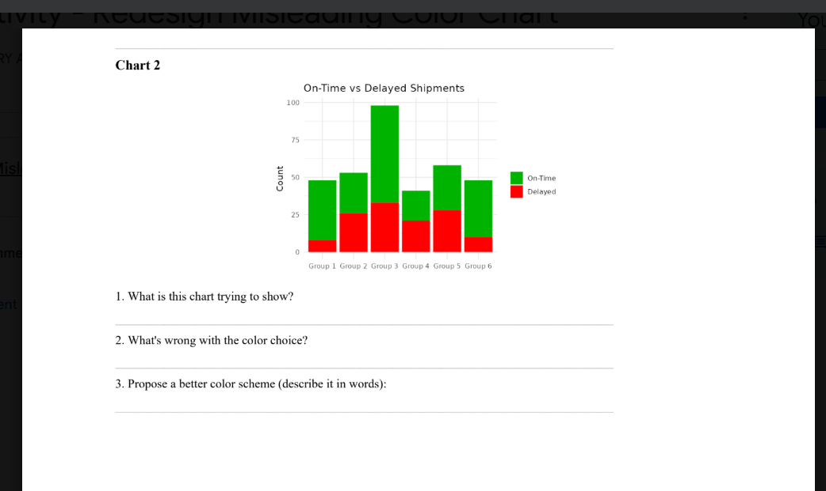
1. What is this chart trying to show?
This chart shows the number of on-time and delayed shipments in different groups. It helps compare the shipment performance of each group.
2. What’s wrong with the color choice?
The colors green and red are very bright and contrasting, which can make the chart difficult to read. Red may also suggest something negative without clearly explaining the data.
3. Propose a better color scheme (describe it in words):
Use blue for on-time shipments and orange for delayed shipments. These colors are clear and easy to distinguish, making the chart more readable.

